Day 29 - 30th Aug 2025

| Dynamo DB | Overview of AWS DynamoDB, Terminology Comparison with SQL, DynamoDB Tables and Naming,Conventions, Data, DynamoDB Consistency Model, DynamoDB Capacity Units, DynamoDB On Demand Capacity, Basics of DynamoDB Partitions, Basics of DynamoDB Indexes, Local Secondary Indexes and Global Secondary Indexes |
| --- | --- |
| Working with DynamoDB using AWS Console3 | Interacting with DynamoDB -Table-level Operations with AWS Console, Item-level Operations with AWS Console, Additional Features in DynamoDB Console |
| Working with DynamoDB using AWS CL | Working with the AWS CLI, Table level Operations with AWS CLI, Write Operations - Item level Operations with AWS CLI, Read Operations - Item level Operations with AWS CLI |
| Working with DynamoDB using AWS SDK | Working with DynamoDB using AWS SDK - Introduction, Table-level Operations with AWS SDK, Write Operations - Item Level Operations with AWS SDK, Conditional Writes - Item Level Operations with AWS SDK, Atomic Counters - Item Level Operations with AWS SDK, Read Operations - Item Level Operations with AWS SDK, Paginated Reads - Item Level Operations with AWS SDK |
| DynamoDB Data Modeling & Best Practices | DynamoDB Architecture, DynamoDB Partitions in Depth, DynamoDB Efficient Key Design, Hot Keys or Hot Partitions, DynamoDB Design Patterns, Multi-value Sorts and Filters, DynamoDB Limits - Error Handling in DynamoDB, Ways to Lower DynamoDB Costs |

Overview of AWS DynamoDB

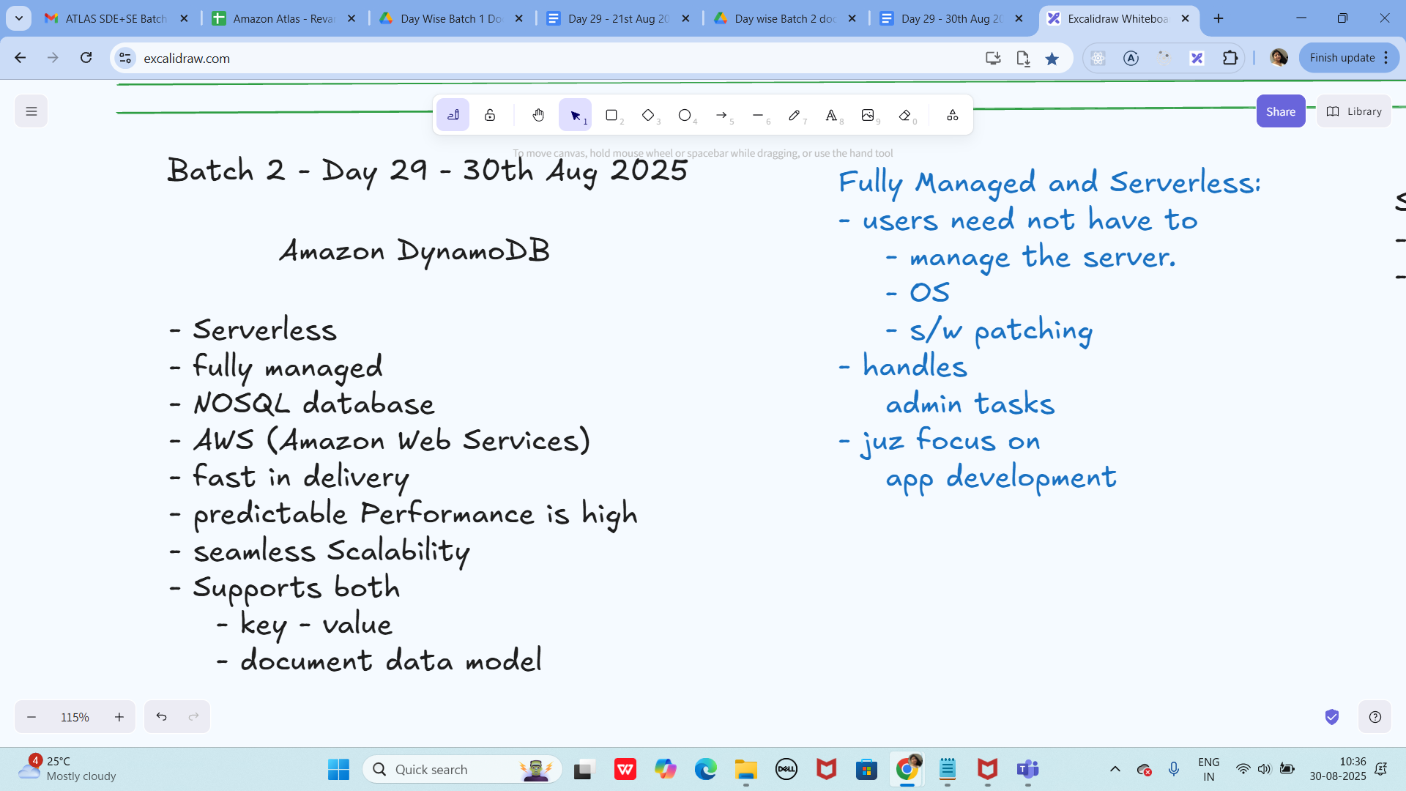

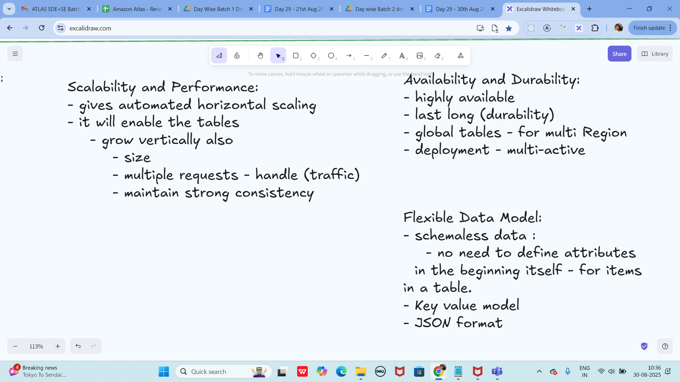

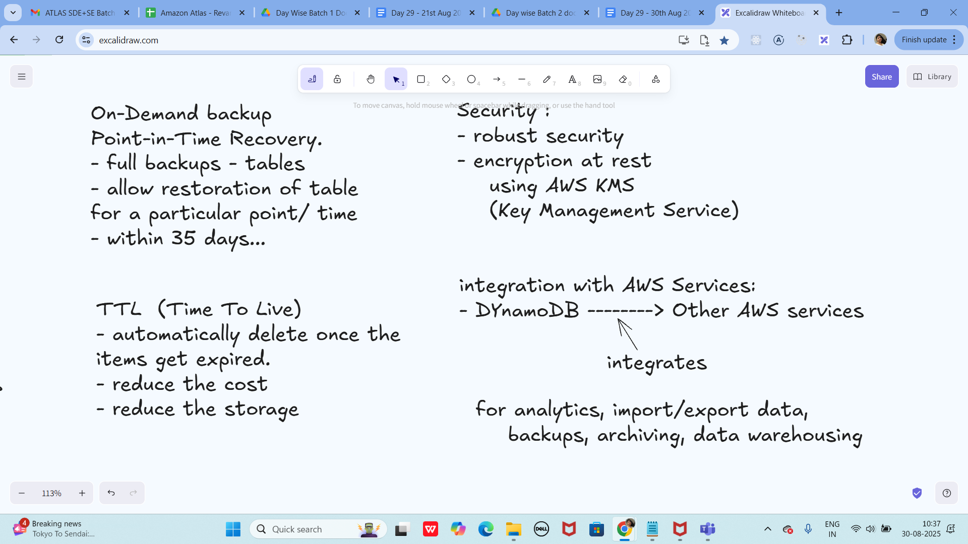

Info Box

Excalidraw updated at 10.35

<https://excalidraw.com/#json=nnj6SG4x2DK356NAcSFCb,0O5S81_CQ3JJ04U97ovWlg>